**United Farmers Q1 Bravoxin offer**

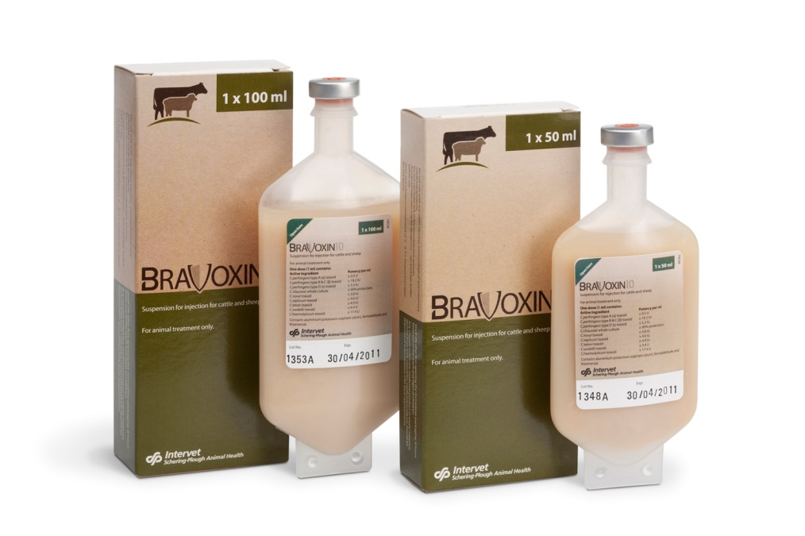

**Given there is likely to be a shortage of Farm packs this season we have the current offer**

**40 get 10 free on 100mls.**

**All orders have to come through your account manager rather than direct**

**Adrian Patterson 07990577052 North England, Scotland**

**Andy Dallyn 07990577021 Central England, Wales**

**Dan Miles 07795520678 Southern England**